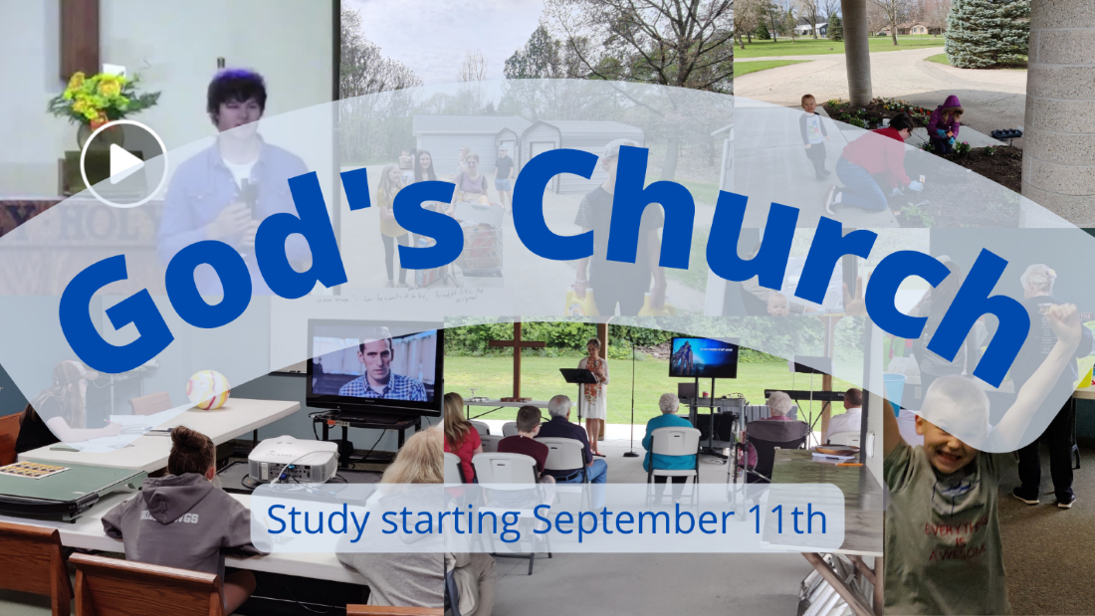

Church, Mission, and Ministry

  - Lesson 8: Renewed vision for ministry

Overview
Lesson 4 surveyed the variety of ways groups of people think about the mission God has given to them.
Lesson 5 surveyed the larger mission of God and considers the work of God’s people in light of his work
Lesson 6 clarified the Church’s mission among God’s many commands
Lesson 7 lets us see how mission becomes ministry
Lesson 8 gives us a new vision for ministry
Lesson 9 builds teamwork in the church among pastors and Christians in general to the common mission
Lesson 10 helps us understand the roles of church workers (pastors, called workers)
Lesson 11 helps us wrap up by seeing how good doctrine shows up in a congregation’s ministry

Getting going
- We’ve established a couple of basic principles about the Church, its mission, and ministry:
- First, the Church is the people who gather around God’s Word and believe that Word.
- Second, the Church does God’s mission. Generally speaking, this means believers work together to apply God’s Word to people so they can be disciples

Getting into God’s Word

- One great example we looked at was the church in Ephesus. In Acts 20:17-38, Paul gave the Ephesian elders a mission, “Keep watch over yourselves and the whole flock” and “be shepherds of the church of God”. But he didn’t tell them what to do – at least not in much detail. He told them more of what to do in Ephesians. Ephesians 4:1-16 is a great section giving the Ephesians a new thought of what their life together could look like. Please read that together.

- What do you think Paul was trying to get the people excited to do? What might have been some ways this was different and new for them?

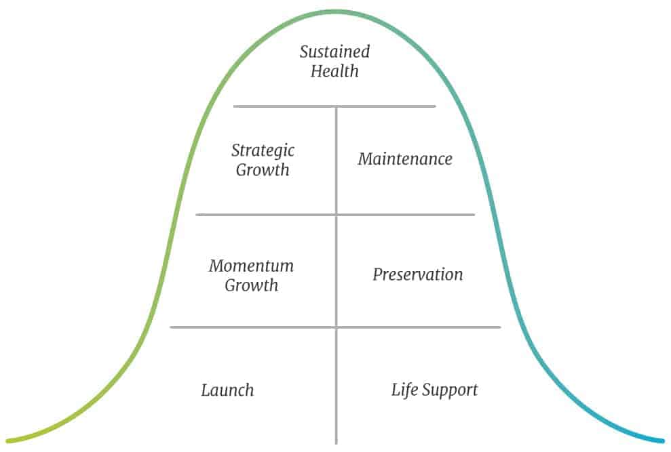
All churches, like all organizations and businesses, have life cycles. The Unstuck Church presents the stages as follows (https://theunstuckgroup.com/phases-church-life-cycle/)

- Who was involved in the work and what were they supposed to do?

- How would they know when they were successful?

- Paul’s idea of ministry that we read in Ephesians 4 is not unique. We can find other examples in Romans 12:4-8, 1 Corinthians 12:4-11, and 1 Peter 4:10-11. What similar ideas show up in these sections?

- Back in Ephesians 4:7-8, God laid out the motivation for this kind of ministry work together. What was it?

- I want to imagine Christmas as a child again for a moment. When you’re grown up, you get gifts for yourself – a new book, a shirt, jewelry, or a tool. But as a child you get Legos, or Magna Tiles, or building blocks, or games. And while it might be your present, it’s only your present for a while. After a few days, everyone else gets to play.
This is the picture of the gospel. The devil is just an adult at Christmas. He’ll take whatever he can get for himself. But not Jesus Christ. Christ wins all of God’s greatest gifts and can’t do anything but share them. His victory over sin and death and evil is not his own. It is ours.
People with new toys play with them. They use them. They enjoy them. That’s our life as God’s people. People enjoying gifts that someone else won for us.

Going forward in faith
- What gifts have you been given as part of God’s kingdom? If you don’t think you have a spiritual gift or recognize your gift, the simplest answer is to pray for God to give you a gift.

- Here is one story of a church that put its gifts to use. “Over the next six months, have as many as half the members invite one new family to church. The council divided up the membership of the church and spent the first sixty days challenging the members to invite someone to church. They met their goal of getting half the congregation to commit to the goal. Every week, Ryan mentioned the effort and incorporated success stories into his sermons. The council sent out text and email reminders to everyone in the effort. By the end of six months, two dozen new families had visited the church and Ryan had received his first phone call from the denominational office.” (The Church Revitalization Checklist, pg 174)

- What’s a passage from this Scripture that impacted you?

- How are you going to respond to this message?

- Who is one person you’d like to share this with?

