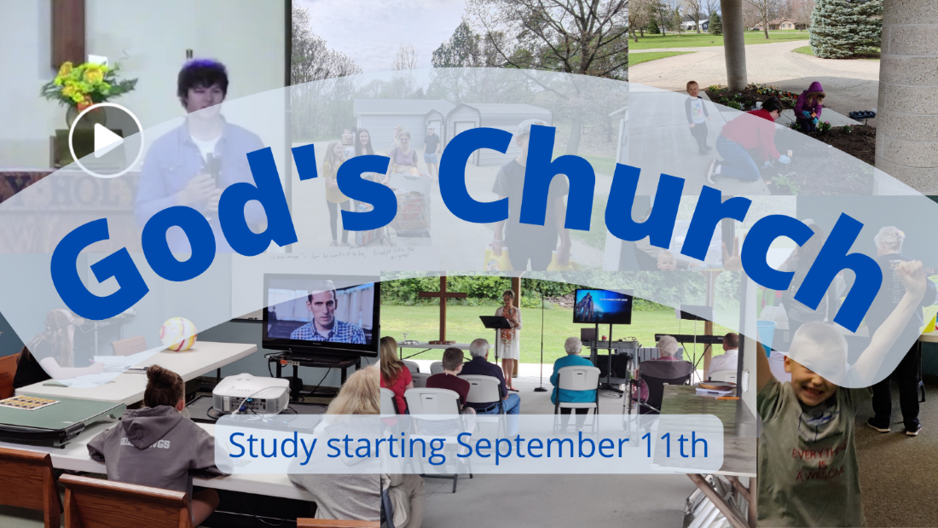

Church, Mission, and Ministry

Lesson 4: Taking a look at the end: Overview of the work of the Church

Getting going
- “The church, faithfully living and teaching the truth of Jesus Christ, is the hope of the world....There is nothing like the local church when it’s working right. Its beauty is indescribable. Its power is breathtaking. Its potential is unlimited. It comforts the grieving and heals the broken in the context of community. It builds bridges to seekers and opens its arms to the forgotten, the downtrodden, and the disillusioned. It breaks the chains of addictions, frees the oppressed, and offers belonging to the marginalized of this world.” (Bill Hybels, https://www.youtube.com/watch?v=twMg2NZKneQ) While there might be many reasons for concern about Bill Hybels because of theology and his life, what God said about his people seems to tell me his right. What do you think? Is he on to something?

- Our study transitions from what the Church is to what the Church does, first looking at what the Church is supposed to do. There are any number of ways that people express what the Church is supposed to do. The first lesson presents the variety of options that churches offer as the mission of the Church and sticks the question in our mind, how do all these churches trying to listen to the Bible end up with such different work? And do some miss what the Bible says?

Getting into God’s Word

- People describe the work God has given to his people in a variety of ways. Here are some options. Spend some time comparing and contrasting these options. What do they say? What are the implications of what they say?

James Jahnke, the author of the study “Church - Mission – Ministry” writes, “Christ gave his church one mission: serve the world with the Word of God.”

Tom Nass writes, “One can say that the church is to preach the gospel, to share the Word of God and the sacraments, to distribute the means of grace, to convey the forgiveness of sins, or to use the keys. The important point is that making the world a better place, in this view, is not really a part of the mission or ministry of the church. The work specially assigned to the church is spiritual work, aimed at conversion and sanctification.” (“The Church and Its Ministry”)

United Church of Christ, “United in Spirit and inspired by God’s grace, we welcome all, love all, and seek justice for all.” Mission - United Church of Christ (ucc.org)

Mark Dever, The Church, “The proper ends for a local congregation’s life and actions are the worship of God, the edification of the church, and the evangelization of the world. These three purposes in turn serve the glory of God.” (pg 69)

Kevin DeYoung “The mission of the church is the task given by God for the people of God to accomplish in the world. In simplest terms, the mission of the church is the Great Commission—what Philip Ryken calls “a clear, unambiguous statement of [the church’s] mission to the world.” “The mission of the church is to go into the world and make disciples by declaring the gospel of Jesus Christ in the power of the Spirit and gathering these disciples into churches, that they might worship the Lord and obey his commands now and in eternity to the glory of God the Father.” The Mission of the Church - The Gospel Coalition

Rick Warren writes, “A purpose-driven church is committed to fulfilling all five tasks that Christ ordained for his church to accomplish.
  - Purpose #1 Love the Lord with all your heart.
  - Purpose #2 Love your neighbor as yourself
  - Purpose #3 Go and make disciples
  - Purpose #4 Baptizing them
  - Purpose #5 Teaching them to obey

Greg Finke writes, “Jesus is in the redemptive process of uniquely preparing each of them to receive what the Father would freely give them: forgiveness of sins and a new life with him forever. That is Jesus’ mission. And he invites us to join him. … He does not give me a mission to do for him. Jesus is on a mission and he invites me to come with him.” (Joining Jesus on His Mission, pg 30)

Klemet Preus writes, “These words (referring to Matthew 28:19-20) are known as the Great Commission. They instruct us in what Jesus wants us to do in order to make disciples. He wants his church to baptize and teach.” (The Fire and the Staff, pg 22)

The ELCA writes, “[The purpose of the Church is to] activate each of us so more people know the way of Jesus and discover community, justice and love.” Mission & Vision - Evangelical Lutheran Church in America (elca.org)

Leslie Newbigin, one of the most famous mission thinkers of the last 100 years wrote, “Christian mission is thus to act out in the whole life of the whole world the confession that Jesus is Lord.”

Christopher Wright writes, ““Fundamentally, our mission (if it is biblically informed and validated) means our committed participation as God’s people, at God’s invitation and command, in God’s own mission within the history of God’s world for the redemption of God’s creation.” (The Mission of God’s people)

John Stott writes, ““To sum up, we are sent into the world, like Jesus, to serve. For this is the natural expression of our love for our neighbors. We love. We go. We serve. And in this we have (or should have) no ulterior motive. True, the gospel lacks visibility if we merely preach it, and lacks credibility if we who preach it are interested only in souls and have no concern about the welfare of people’s bodies, situations and communities. Yet the reason for our acceptance of social responsibility is not primarily in order to give the gospel either a visibility or credibility it would otherwise lack, but rather simple uncomplicted compassion.”

Forefront Church writes, “We believe that the death and resurrection of Jesus Christ is good news for everyone regardless of sexual orientation, identity, ethnicity, and tradition. All are affirmed, included, and invited to join us in this Christ-following journey. We’re a church dedicated to serving each other and restoring neighborhoods, living out the great commandment to love God and love your neighbor as yourself.” Forefront 101 - Google Docs

- Agree or disagree. If you watched Jesus live, suffer, die, and rise, you would have thought that you were supposed to forgive the world.

- I appreciate how Jude warns us about people who mislead us while keeping us active in God’s mission and work. Please read Jude 17-23.
What kind of people does Jude warn us about (see especially verses 17-19)?
How does Jude describe the mission of the Church in verses 20-23?

Going forward in faith
- What we think of as the mission of God’s people is vitally important.
On the one hand, writers like the Lutheran Alvin Schmidt can say, “This man’s unique and exemplary life, and his suffering, death, and physical resurrection from the dead transformed his handpicked disciples as well as the lives of many others. As he once said, “I came that [you] may have life, and have it abundantly” (John 10:10 NRSV). The lives that he transformed in turn changed and transformed much of the world: its morals, ethics, health care, education, economics, science, law, the fine arts, and government. These changes, often not recognized, are still largely operative in the West, continuing to produce many positive effects that are also present in some non-Western areas of the world.” (How Christianity Changed the World)
On the other hand, plenty of non-religious people say all the time, the world would be better off with God and religion and the church needs to go away.

I don’t think it is a stretch to say both of these facts are true – there are always people who feel like God and churches should go away; and that the followers of Jesus have significantly changed the world. How can both of these things be true? If they are both true, how do believers in Jesus live with these seemingly contradictory truths?

- What’s a passage from this Scripture that impacted you?

- How are you going to respond to this message?

- Who is one person you’d like to share this with?

